**Details of your portfolio**

PD URL site *(*Compulsory to fill up for milestone 2 and 3):*

[**https://mardhiah-portfolio.netlify.app/**](https://mardhiah-portfolio.netlify.app/)

Name of your portfolio:

*Mardhiah Azli*

Your Logo:



Describe your target audience:

*My target audience is mainly* ***students, young professionals, and potential employers*** *in the fields of* ***UI/UX, web development, mobile development, and digital design****. Most are aged* ***17–40*** *and based in* ***Singapore****, with diverse cultural backgrounds and a basic to strong understanding of design and tech.*

*They value* ***creativity, clarity, and thoughtful design****. They appreciate work that shows good problem-solving, visual storytelling, and technical skill. This audience is often looking for portfolios that are* ***professional, well-crafted, and easy to navigate****, whether for inspiration, collaboration, or assessing my suitability for internships and opportunities.*

Describe your brand story/ purpose:

*I’m Mardhiah — a Digital Design & Development student who loves blending storytelling with technology. My journey started from a fascination with beautiful interfaces and grew into a passion for creating experiences that feel thoughtful, immersive, and visually compelling.*

*I’m inspired by dark-academia aesthetics, interactive media, and meaningful user experiences. Through my work in UI/UX, web development, and mobile development, my purpose is to design digital experiences that reflect creativity, intention, and emotional depth. I want my audience to feel the care behind every detail — from layout to interaction — and to see how design and development come together to tell a story.*

**Design brief**

Colour scheme & Colour palette:

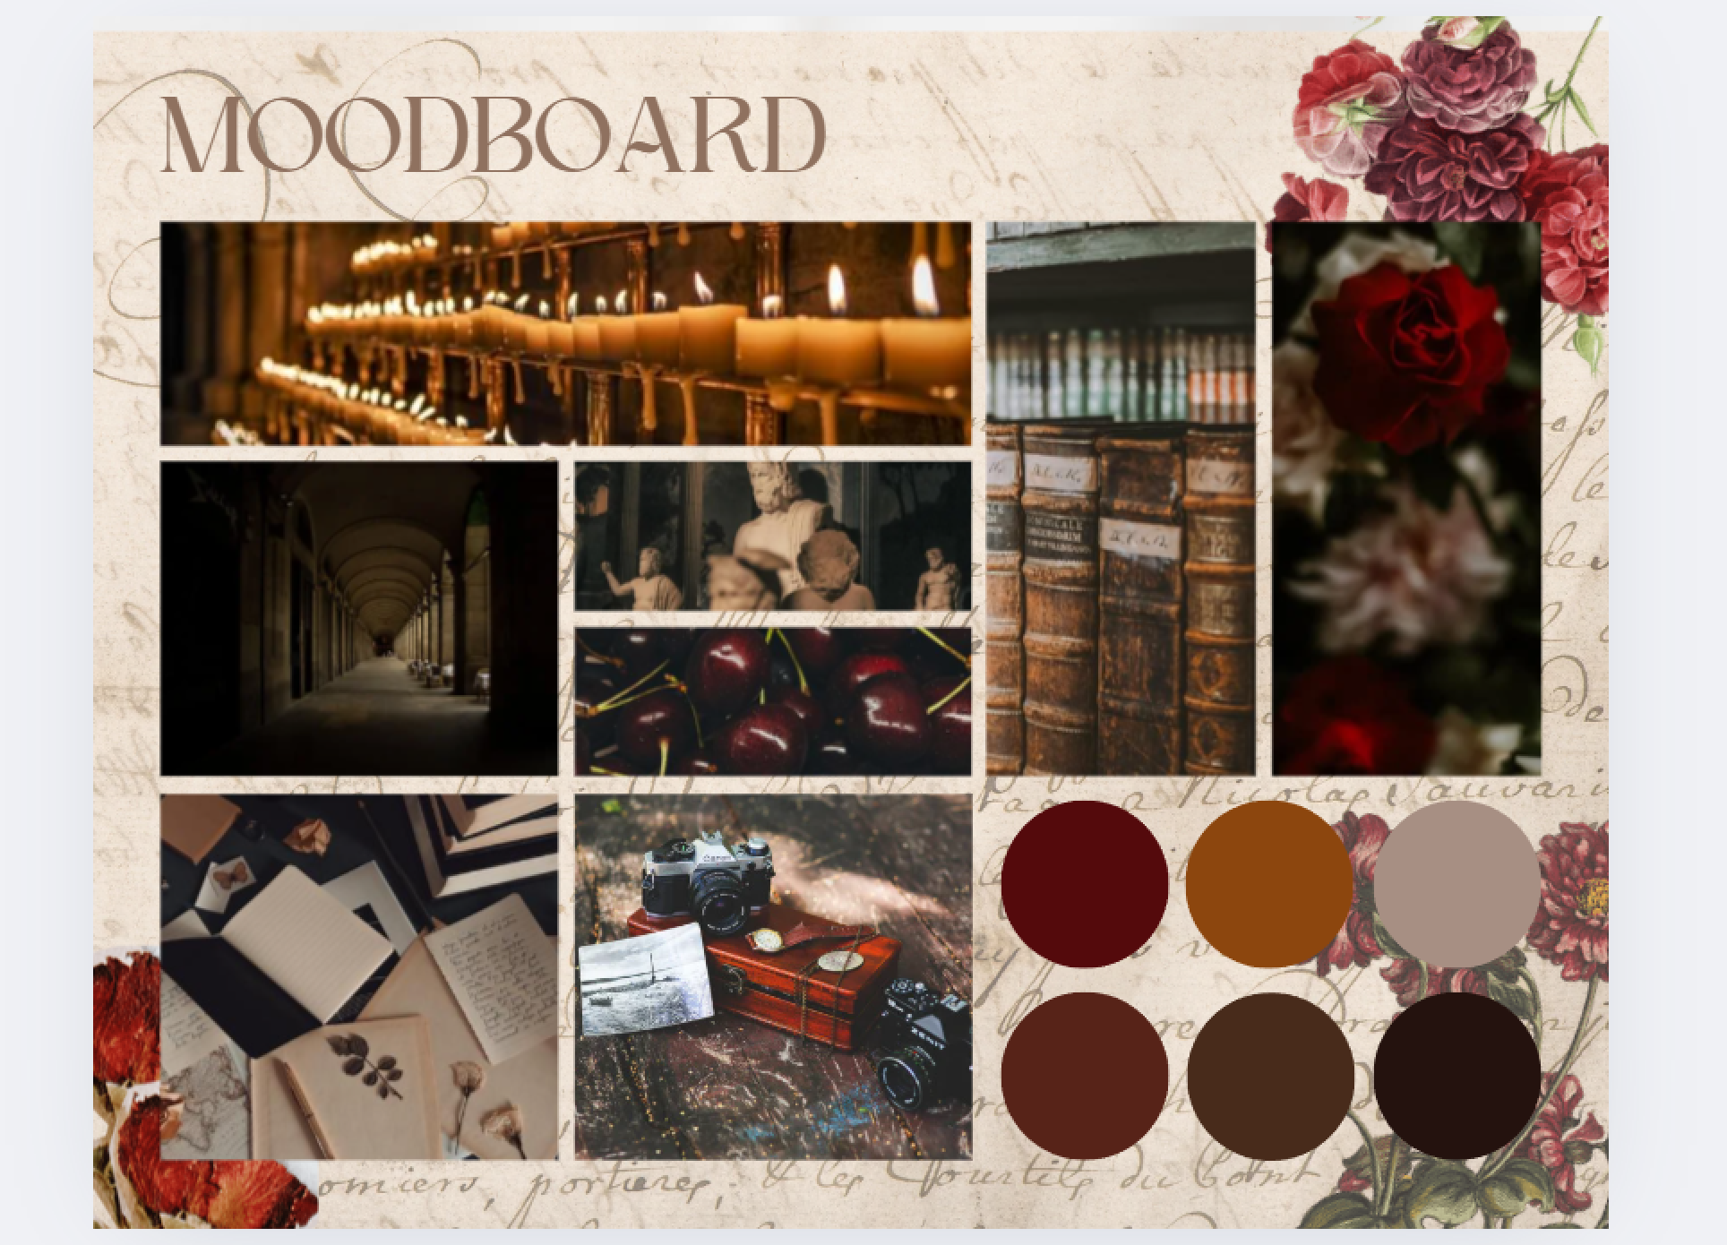

Typography:

*What is the fonts type used?*

Cormorant Garamond  
Playfair Display

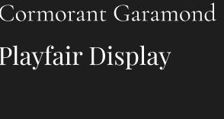

Theme:

*Dark Academia*

Layout/ Arrangement:

*How will you arrange the multimodal composition in a way that makes sense for your audience and your purpose? How might you arrange ideas and elements so that your composition is effective?*

***Minimally 3 tabs with 2 layers of navigation***

Opening page/Home

Experience

Projects

Contact

About Me

Mobile Development

Web developement

Designs

**Low fidelity wireframe:**

*Insert your low-fidelity wireframe here. This can be photo of your sketches or digitally created low-fidelity wireframe using shapes. E.g.*

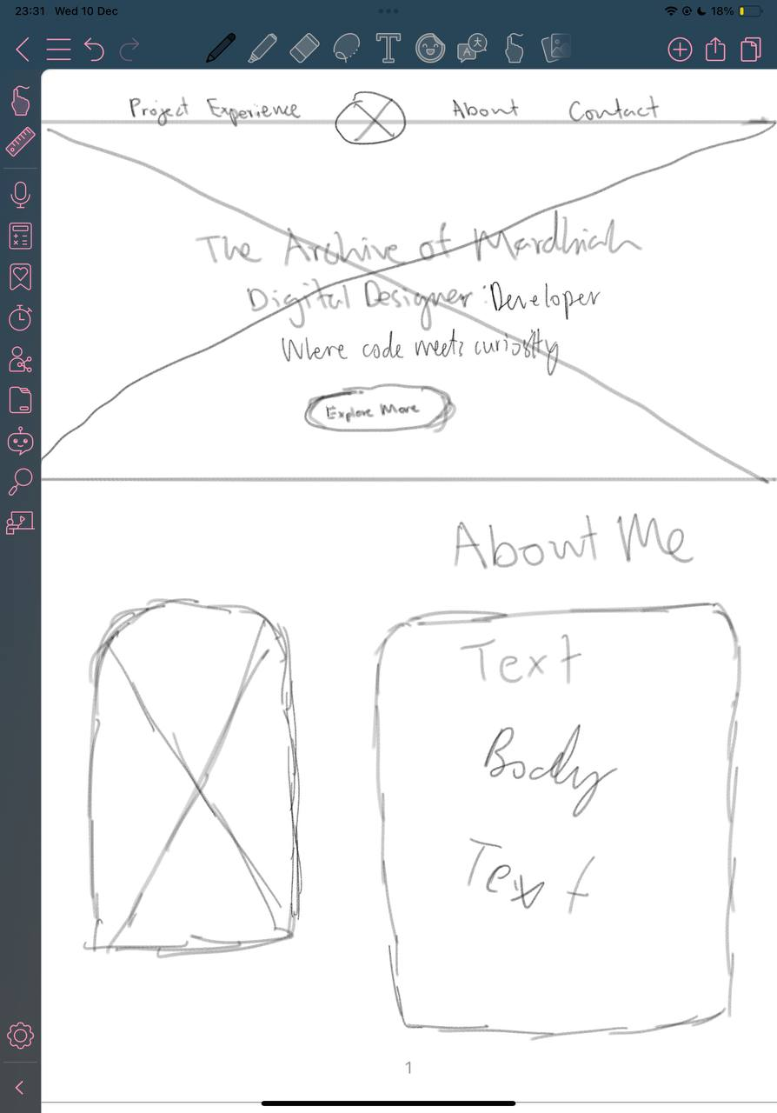

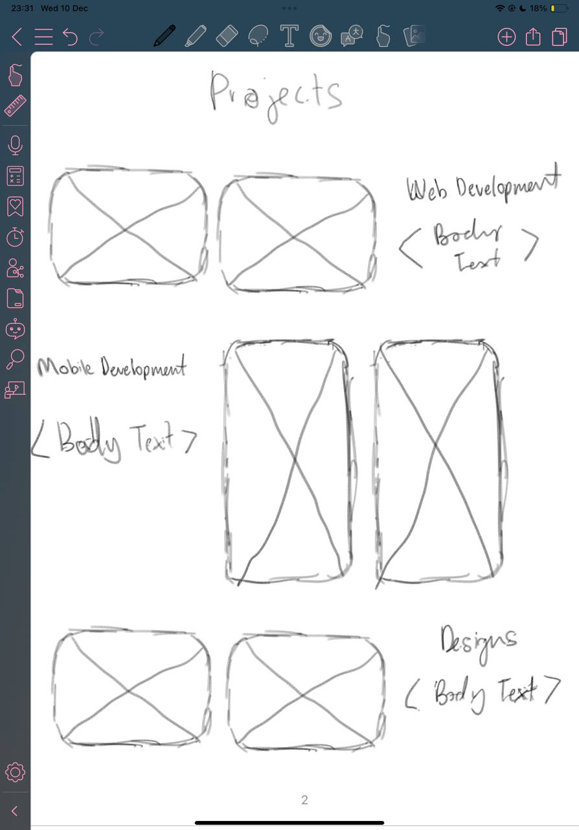

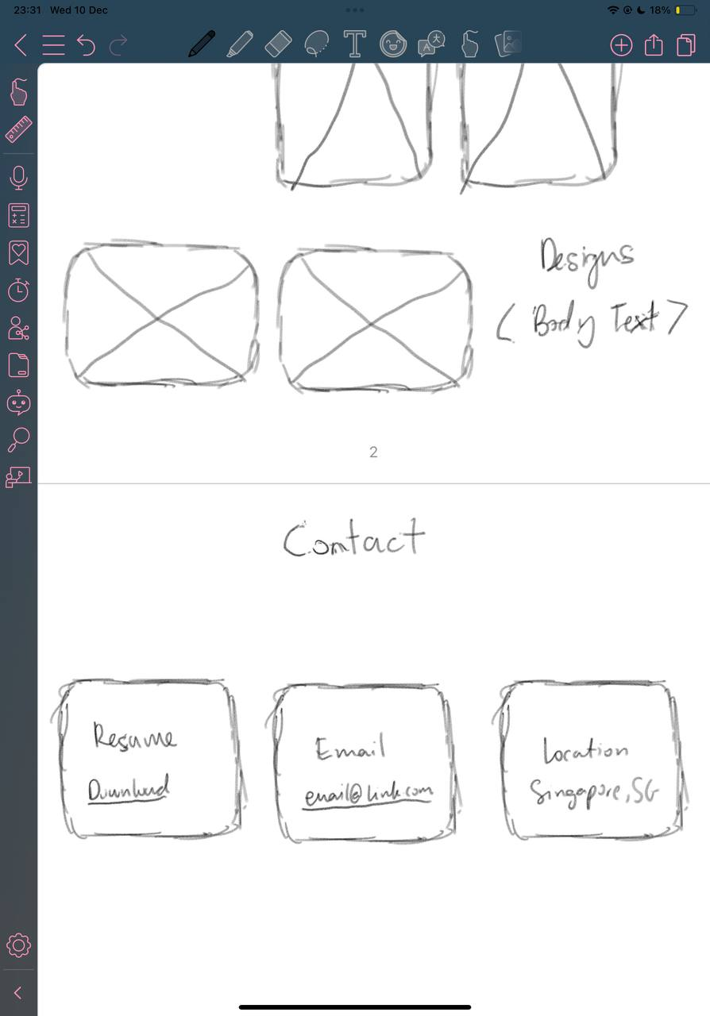

**High fidelity wireframe** *(*Compulsory to fill up for milestone 2 and 3)***:**

*Insert your high-fidelity wireframe here. Full set of ALL the pages in JPEG or PDF format.*

*E.g.*

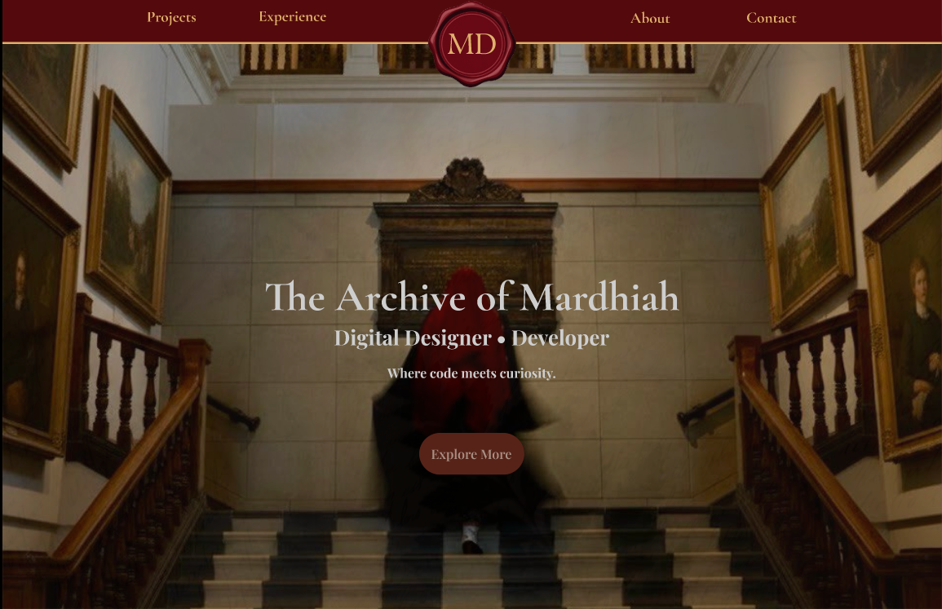

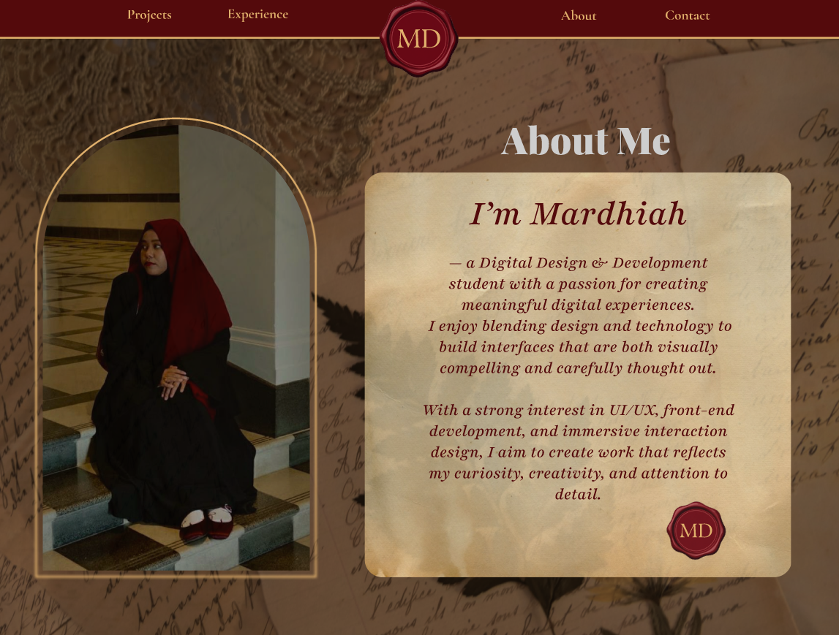

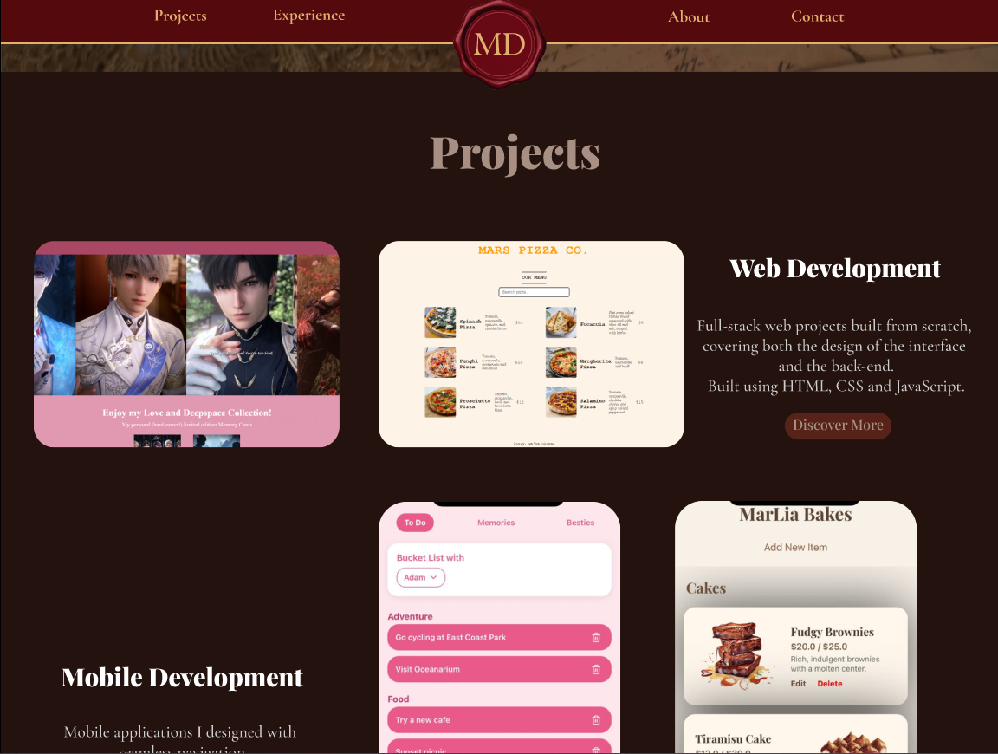

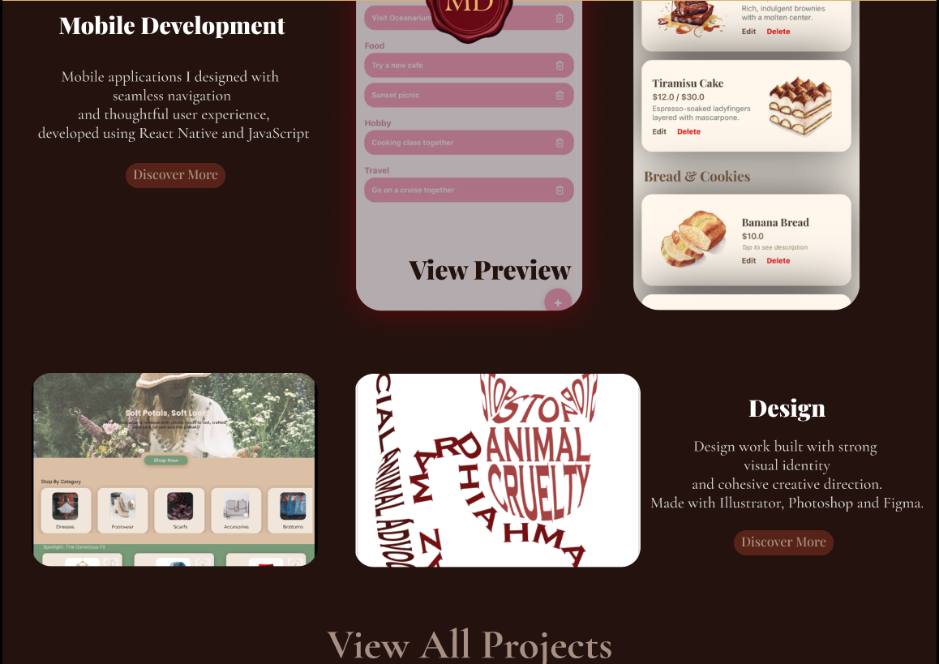

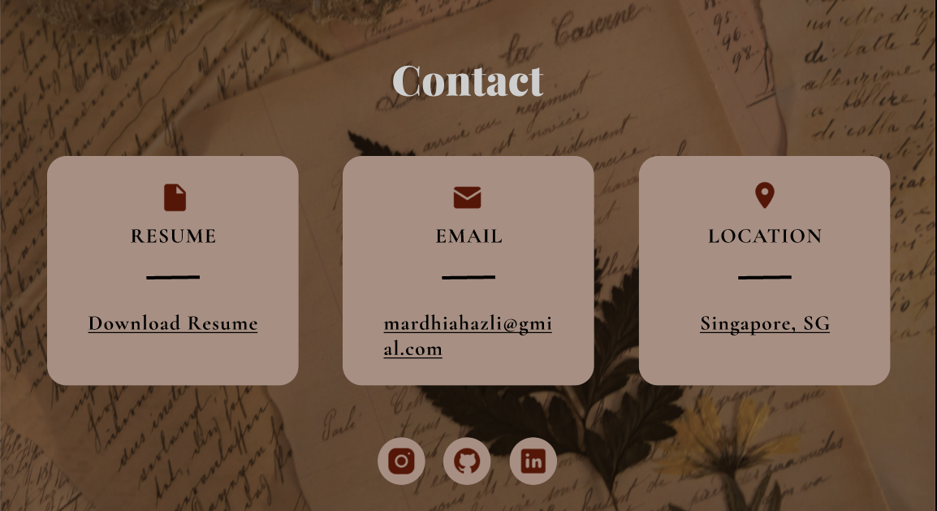

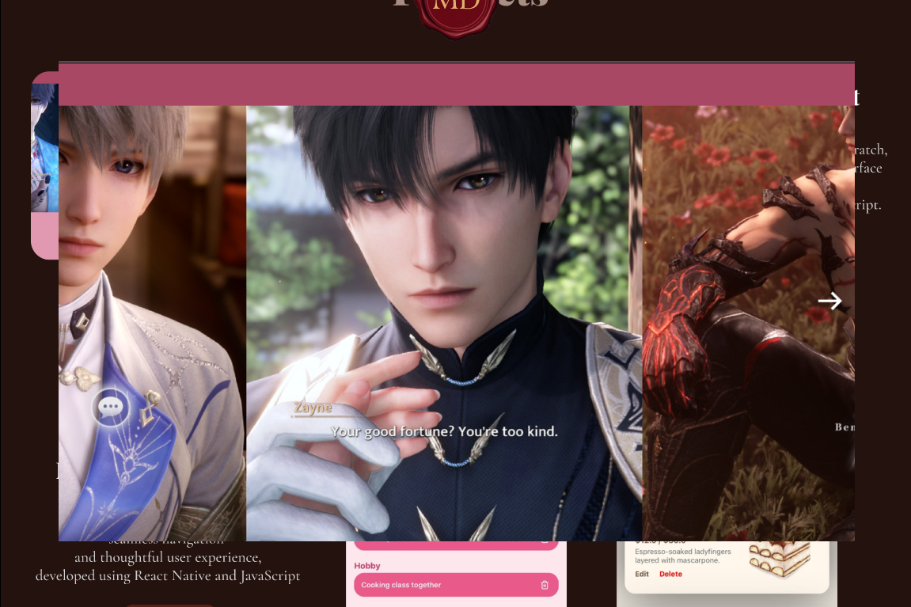

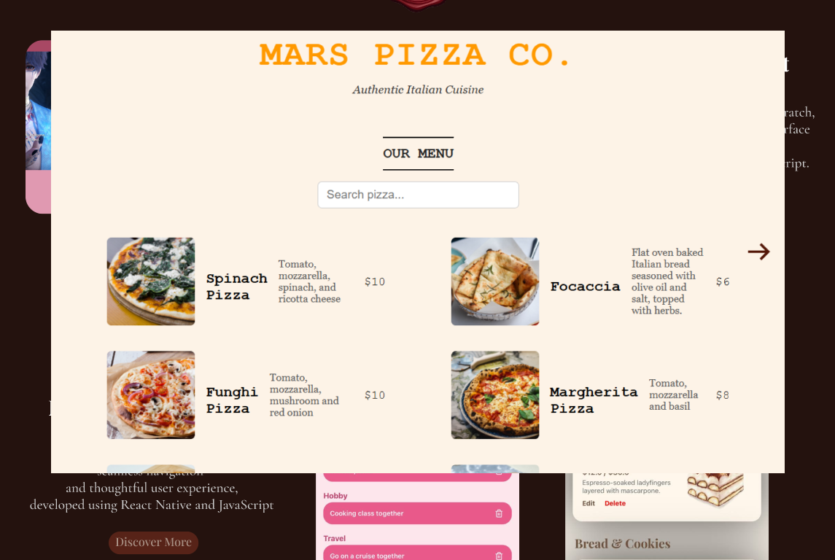

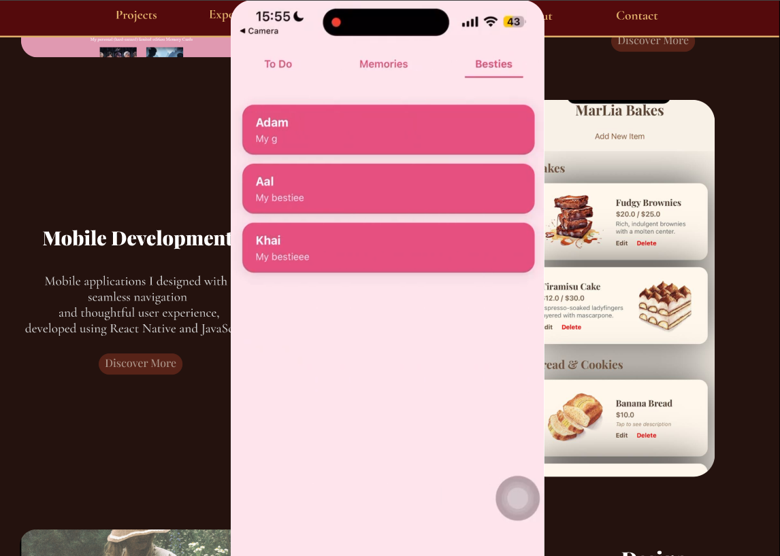

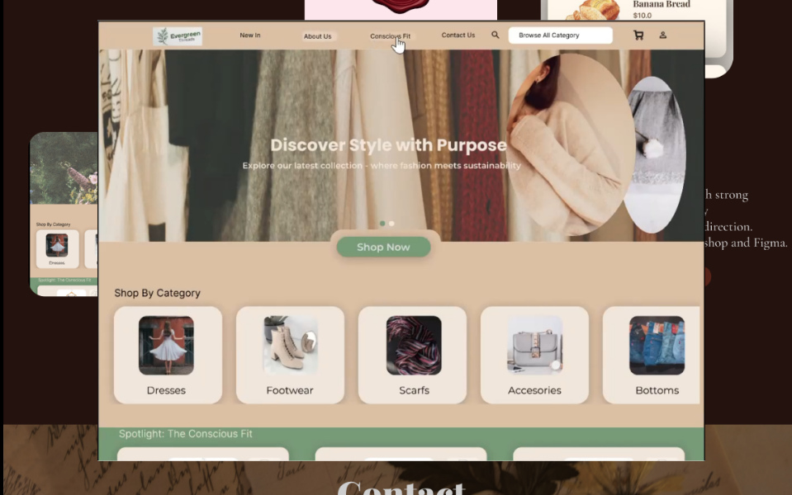

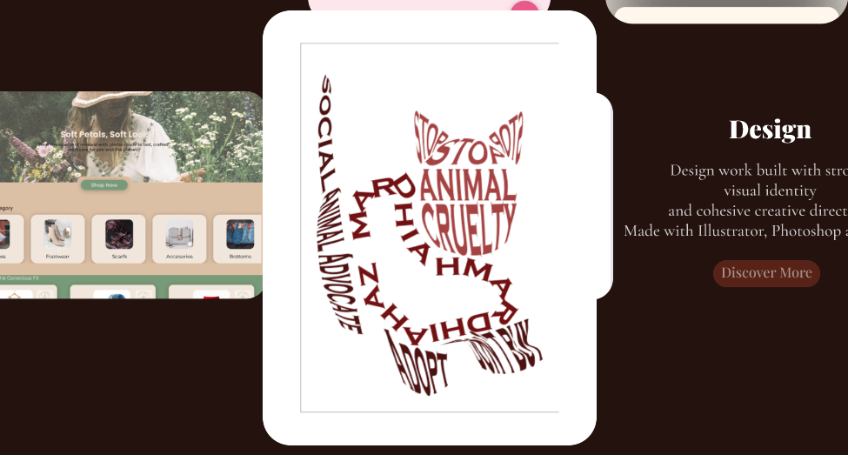

**Link to your Prototype – Most likely on Figma (make sure your lecturer is given access to the site)** *(To fill up for milestone 2 and 3)***:**

**1**[**https://www.figma.com/design/WvqP4xxbzmWVcpAtQiSMTu/Untitled?node-id=97-24&t=MoSqynmqsBbUKTm4-1**](https://www.figma.com/design/WvqP4xxbzmWVcpAtQiSMTu/Untitled?node-id=97-24&t=MoSqynmqsBbUKTm4-1)

**Reference sites** *(*Optional)***:**

*Any reference websites you have make references*

*Behance.net*

*Pinterest.com*